**# Creating and Deploying a Static Website with Apache2:**

**Preparation (5 minutes)**

* Ensure you have access to a Linux environment (e.g., virtual machines, EC2 instances, or local installations) with sudo privileges.

**# Activity Breakdown:**

**# Part 1: Installing Apache2 (5 minutes):**

**1. Update Package Lists:**

- Open the terminal and run:

sudo apt update

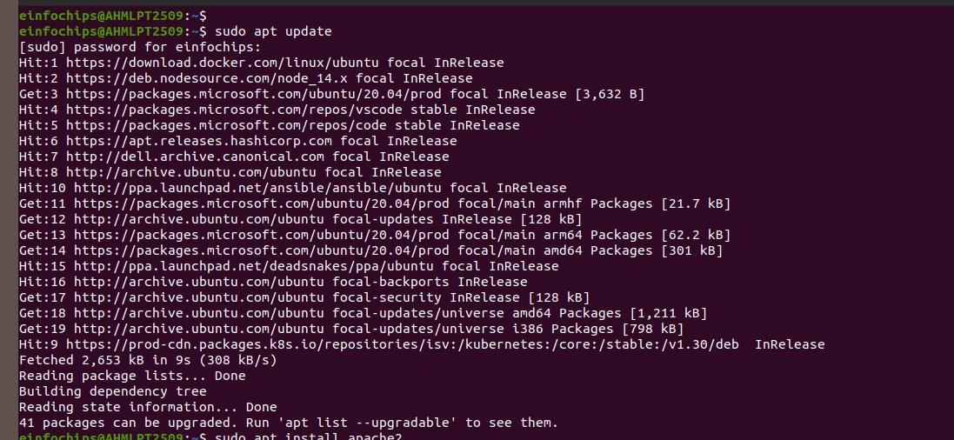

**2. Install Apache2:**

- Install Apache2 by running:

sudo apt install apache2

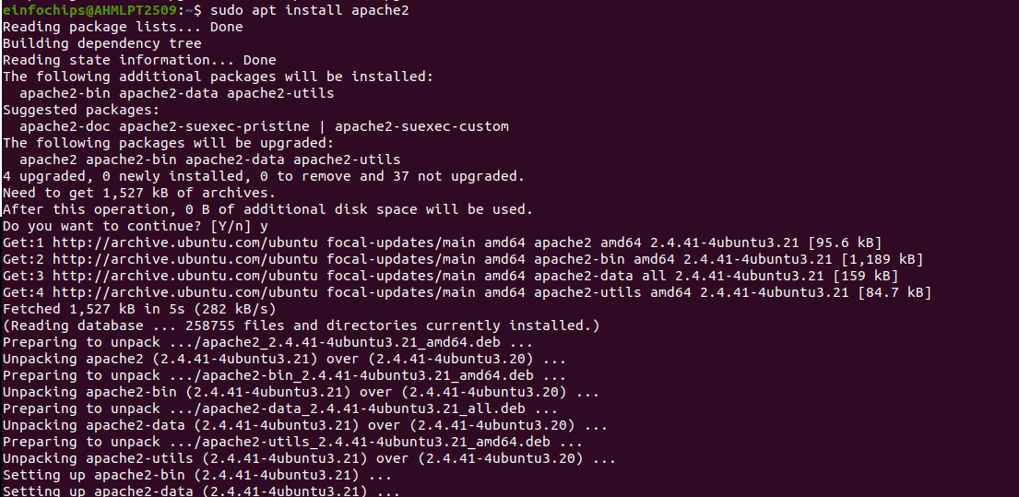

**3. Start and Enable Apache2:**

- Start the Apache2 service:

sudo systemctl start apache2



**4. Enable Apache2 to start on boot:**

sudo systemctl enable apache2



**5. Verify Installation**

* + Open a web browser and navigate to <http://your_server_ip>. You should see the Apache2 default page.

#### **# Part 2: Creating the Website (10 minutes):**

**1. Navigate to the Web Directory:**

- Change to the web root directory:

cd /var/www/html

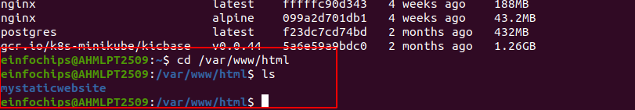

**2. Create a New Directory for the Website:**

Create a directory named mystaticwebsite:

sudo mkdir mystaticwebsite

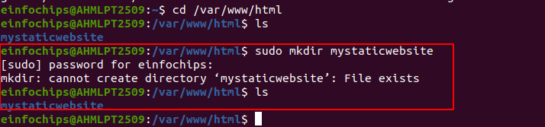

**3. Change ownership of the directory:**

sudo chown -R $USER:$USER /var/www/html/mystaticwebsite

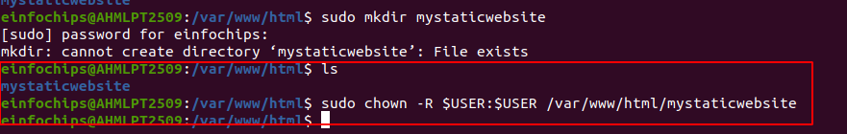

**4. Create HTML File:**

Create and edit the index.html file:

nano /var/www/html/mystaticwebsite/index.html

**5. Add the following content:**

<!DOCTYPE html>

<html>

<head>

<title>My Static Website</title>

<link rel="stylesheet" type="text/css" href="styles.css">

</head>

<body>

<h1>Welcome to My Static Website</h1>

<p>This is a simple static website using Apache2.</p>

<script src="script.js"></script>

</body>

</html>

* Save and exit (Ctrl+O, Enter, Ctrl+X).

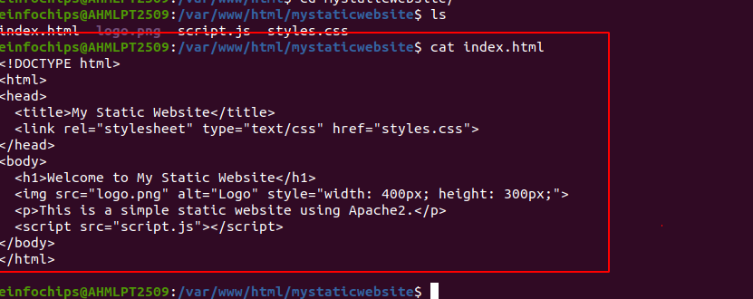

**6. Create CSS File:**

* Create and edit the styles.css file:  
    
  nano /var/www/html/mystaticwebsite/styles.css



**7. Add the following content:**

body {

font-family: Arial, sans-serif;

background-color: #f0f0f0;

text-align: center;

margin: 0;

padding: 20px;

}

h1 {

color: #333;

}

* ave and exit (Ctrl+O, Enter, Ctrl+X).

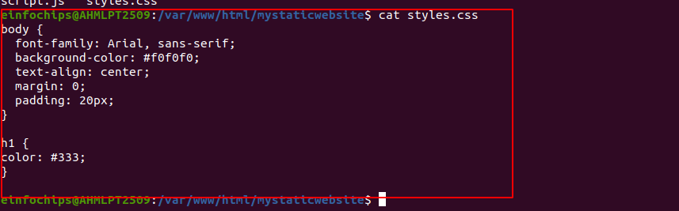

**8. Add an Image:**

1. Download or copy an image file (e.g., logo.png) to the website directory:

cp /path/to/your/logo.png /var/www/html/mystaticwebsite/logo.pn

cp /home/einfochips/Desktop/Shital/logo.png /var/www/html/mystaticwebsite/logo.png

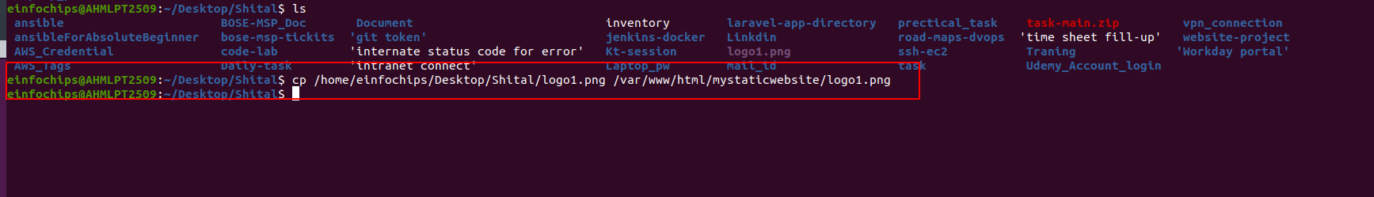

**9. Update index.html to include the image:**

nano index.html

cat index.html

<body>

<h1>Welcome to My Static Website</h1>

<img src="logo.png" alt="Logo">

<p>This is a simple static website using Apache2.</p>

<script src="script.js"></script>

</body>

**OR**

!DOCTYPE html>

<html>

<head>

<title>My Static Website</title>

<link rel="stylesheet" type="text/css" href="styles.css">

</head>

<body>

<h1>Welcome to My Static Website</h1>

<img src="logo.png" alt="Logo" style="width: 400px; height: 300px;">

<p>This is a simple static website using Apache2.</p>

<script src="script.js"></script>

</body>

</html>

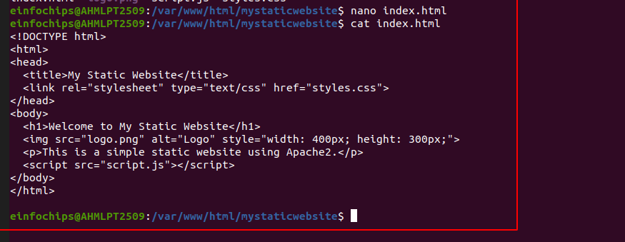

#### **# Part 3: Configuring Apache2 to Serve the Website (10 minutes):**

**1. Create a Virtual Host File:**

Create and edit the virtual host configuration file:

sudo nano /etc/apache2/sites-available/mystaticwebsite.conf

cd /etc/apache2/sites-available/

sudo nano mystaticwebsite.conf

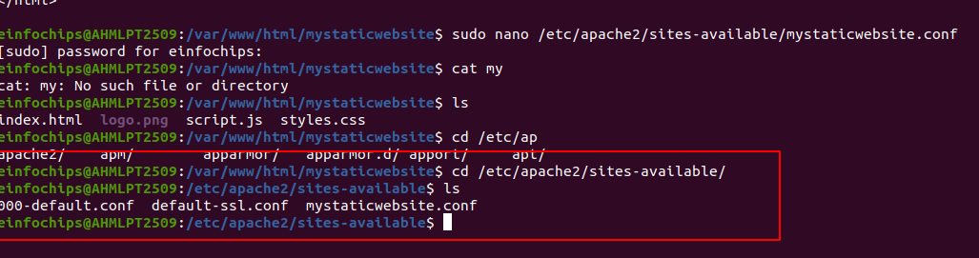

**Add the following content:**

<VirtualHost *:80>

ServerAdmin webmaster@localhost

DocumentRoot /var/www/html/mystaticwebsite

ErrorLog ${APACHE_LOG_DIR}/error.log

CustomLog ${APACHE_LOG_DIR}/access.log combined

</VirtualHost>

* Save and exit (Ctrl+O, Enter, Ctrl+X).

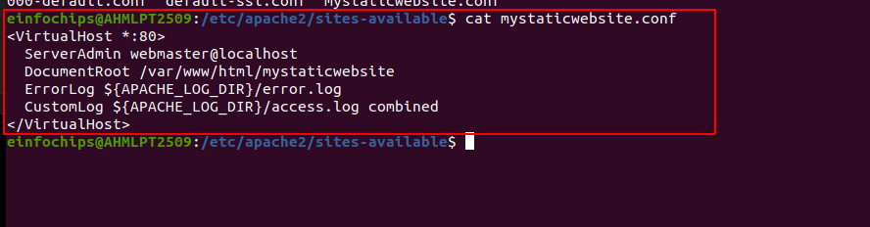

**2. Enable the New Virtual Host:**

Enable the virtual host configuration:

sudo a2ensite mystaticwebsite.conf

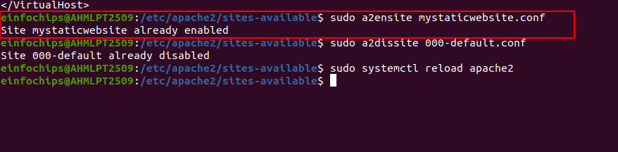

**3. Disable the Default Site:**

Disable the default site configuration:

sudo a2dissite 000-default.conf

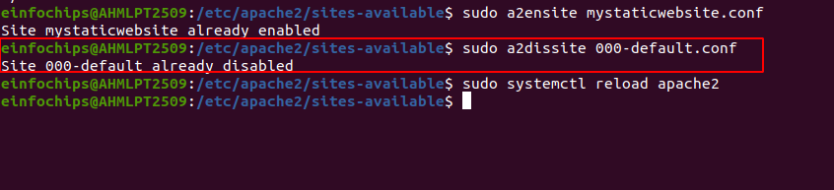

**4. Reload Apache2:**

Reload the Apache2 service to apply the changes:

sudo systemctl reload apache2

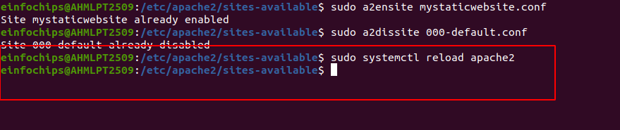

**5. Test the Configuration:**

* + Open a web browser and navigate to <http://your_server_ip>. You should see the static website with the HTML, CSS, JS, and image.
* <http://127.0.0.0/>
* http://localhost/

